EEE8010

# Exam Question on VLEs

Section B, Question 4

a)

Given an arbitrary sequence ‘ $S_{N}$’, of messages the probability of that particular sequence in terms of the probabilities of the individual messages within it is given by:

$P\left(S_{N}\right)= \sum_{i=1}^{N}{P_{i}^{NP_{i}}}$

To encode such a sequence we need $L_{N}$ bits, i.e.:

$$L_{N}=\log_{2}⁡\left(\frac{1}{P\left(S_{N}\right)}\right)$$

Expanding the $P(S_{N}$) summation gives:

$$L_{N}=\log_{2}\frac{1}{P_{1}^{NP_{1}}×P_{2}^{NP_{2}}×P_{3}^{NP_{3}}×⋯{×P}_{n}^{NP_{n}}}$$

Rearranging gives:

$$L_{N}= \left(\log_{2}\frac{1}{P_{1}^{NP_{1}}}\right)+\left(\log_{2}\frac{1}{P_{2}^{NP_{2}}}\right)+\left(\log_{2}\frac{1}{P_{3}^{NP_{3}}}\right)+⋯+\left(\log_{2}\frac{1}{P_{n}^{NP_{n}}}\right)$$

$$= \sum_{k=1}^{n}{\log_{2}\frac{1}{P_{k}^{NP_{k}}}}$$

Using logarithmic identities, we can rearrange this as follows:

$$L_{N}=N\sum_{k=1}^{n}{P_{k}\log_{2}\frac{1}{P_{k}}}$$

Thus as $L_{N}$ is the minimum number of binary digits to encode N messages, to find L, the average number of binary digits to encode one message, we simply divide by the number of messages as given by:

$L=\left(\frac{L_{N}}{N}\right)$ = H(m) = entropy of the source

b)

|  |  |  |
| --- | --- | --- |
| Symbol | Source Code | Length |
| a | 11 | 2 |
| e | 10 | 2 |
| i | 110 | 3 |
| o | 01 | 2 |
| u | 1110 | 4 |
| ! | 1111 | 4 |

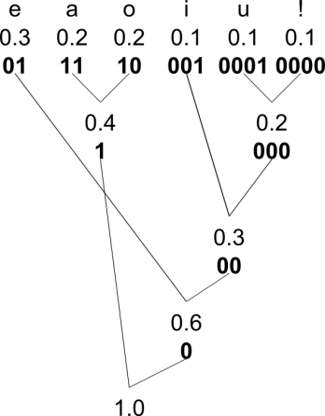

c) **Pseudo Code for an Arithmetic Decoder:**

Value = ConvertToValue(Code);

do

{

S = FindSymbolWhere(Value < RangeHigh(S) && Value >= RangeLow(S));

Output(S);

Low = RangeLow(S);

High = RangeHigh(S);

Range = High-Low;

Value = (Value – Low) / Range;

} until (S == ‘!’)

**Range Listing:**

|  |  |  |
| --- | --- | --- |
| Symbol | RangeLow | RangeHigh |
| a | 0.0 | 0.2 |
| e | 0.2 | 0.5 |
| i | 0.5 | 0.6 |
| o | 0.6 | 0.8 |
| u | 0.8 | 0.9 |
| ! | 0.9 | 1.0 |

**Decoding:**

|  |  |  |  |  |  |
| --- | --- | --- | --- | --- | --- |
| Iteration | Value | Output | Low | High | Range |
| 1 | 0.23355 | ‘e’ | 0.2 | 0.5 | 0.3 |
| 2 | 0.1118 $\dot{3}$ | ‘ea’ | 0 | 0.2 | 0.2 |
| 3 | 0.5591 $\dot{6}$ | ‘eai’ | 0.5 | 0.6 | 0.1 |
| 4 | 0.591 $\dot{6}$ | ‘eaii’ | 0.5 | 0.6 | 0.1 |
| 5 | 0.91 $\dot{6}$ | ‘eaii!’ | 0.9 | 1 | 0.1 |
| 6 | 1. $\dot{6}$ | STOP (terminator reached) |  |  |  |